CPE 400 Computer Communication Networks

FALL 2022

Sample Project Topics for CPE 400 (Students can choose their own topics as well; must confirm with the instructor first)

**(1) Dynamic routing mechanism design with focus on throughput**

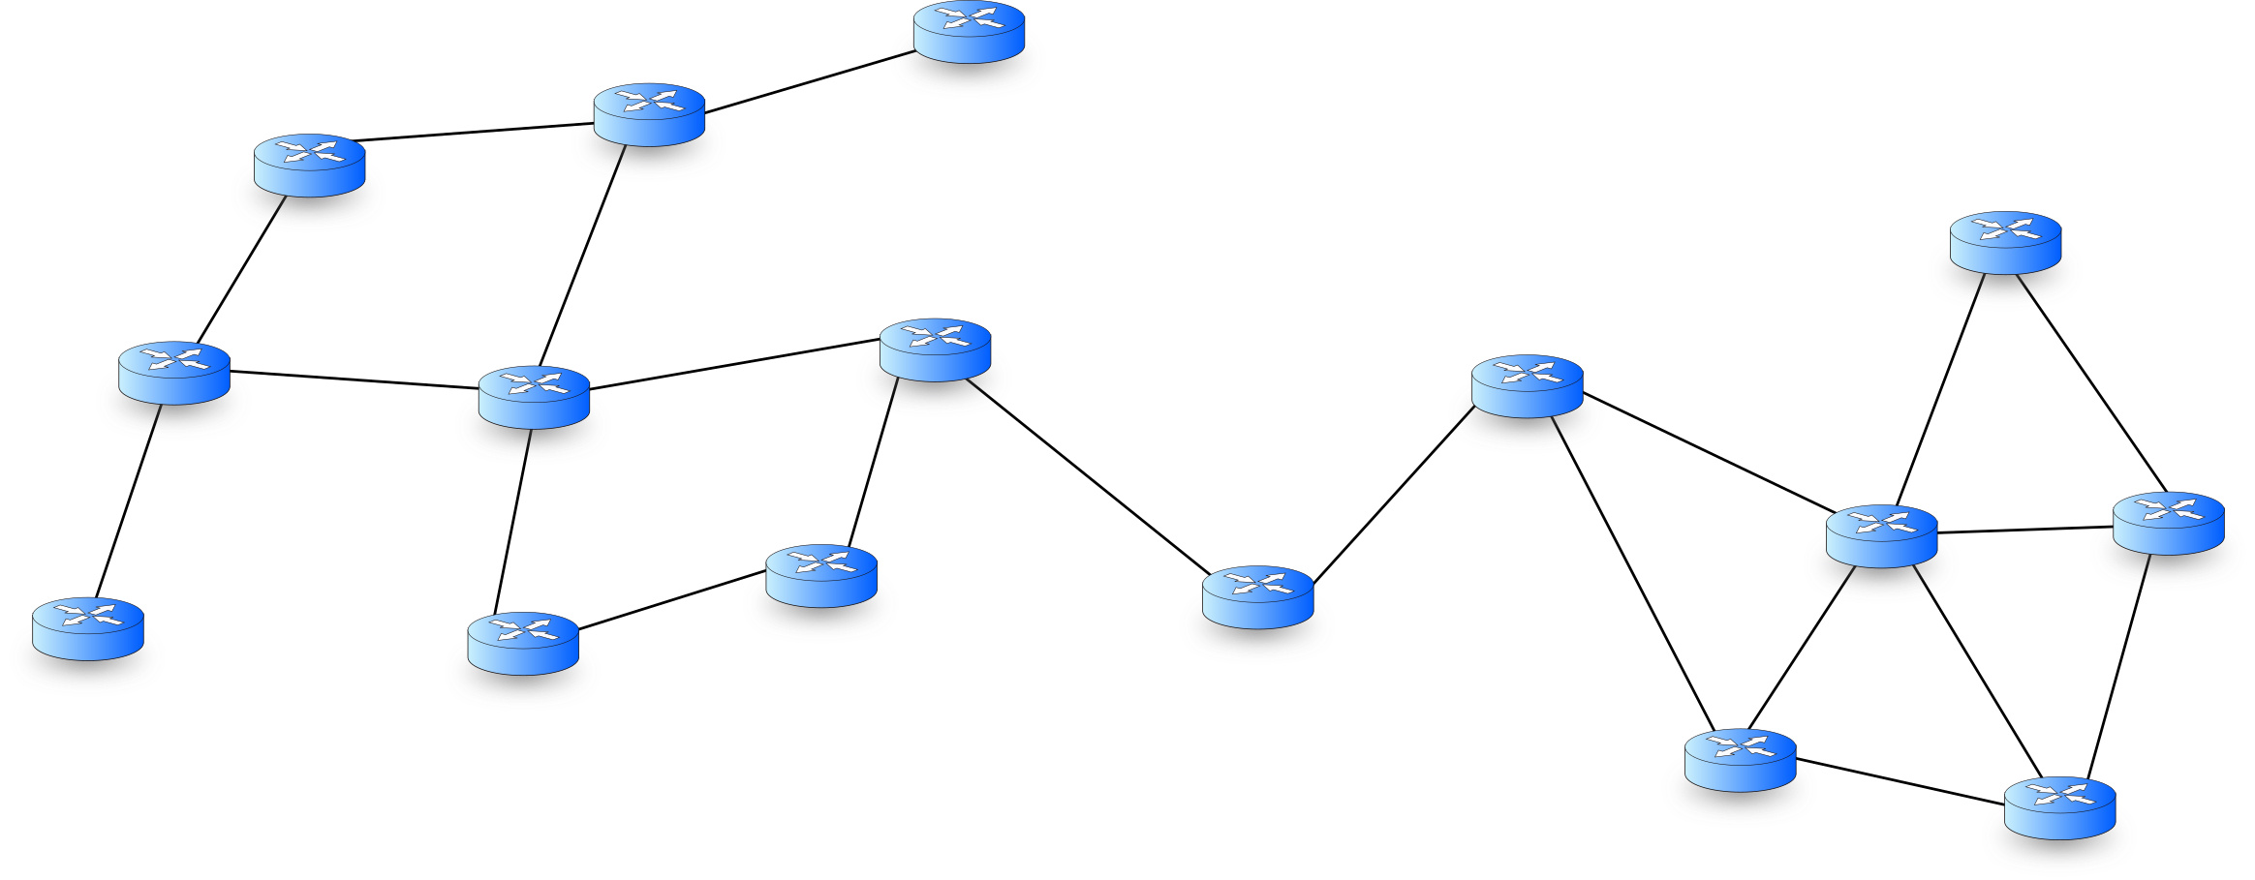Figure 1 ‑ Generic network of routers

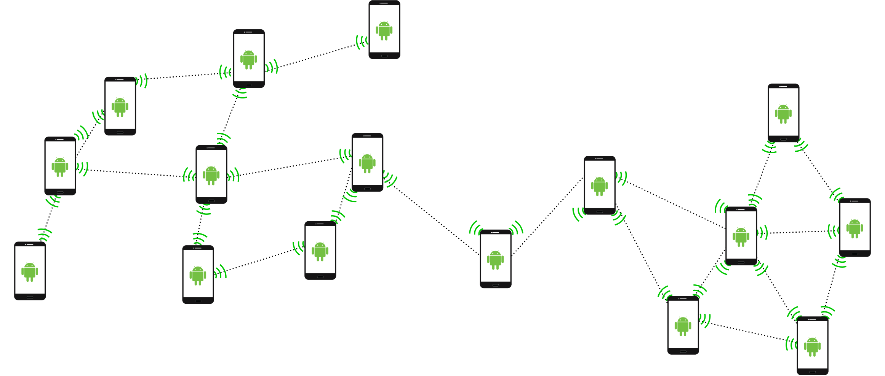Figure 2 ‑ Same topology as Figure 1, but now all links are wireless, and each device can be both source of traffic and also act as a relay

Create and simulate a new routing strategy that maximizes the overall throughput of a mesh network. Throughput is affected by many factors that should be considered, such as nodal processing delay, overloaded buffers, loss, etc. The more realistic assumptions you can make for your network, better it is.

**(2) Dynamic routing mechanism design with focus on energy conservation**

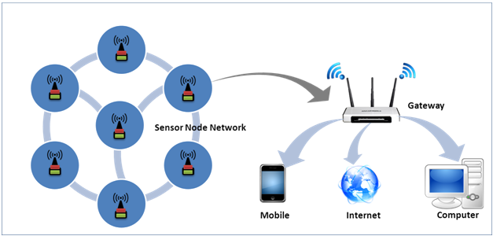Figure 3 ‑ Wireless Sensor Network example

Create and simulate a sensor network. The objective is to increase the longevity of the network by using dynamic routing. Sensors are energy constrained and are not super powerful like common computers. Every time a sensor transmits some packets, it will decrease the amount of energy left. The team will create a dynamic routing scheme to try and maintain all nodes of the network online for as long as possible.

**(3) Hybrid dynamic routing mechanism design**

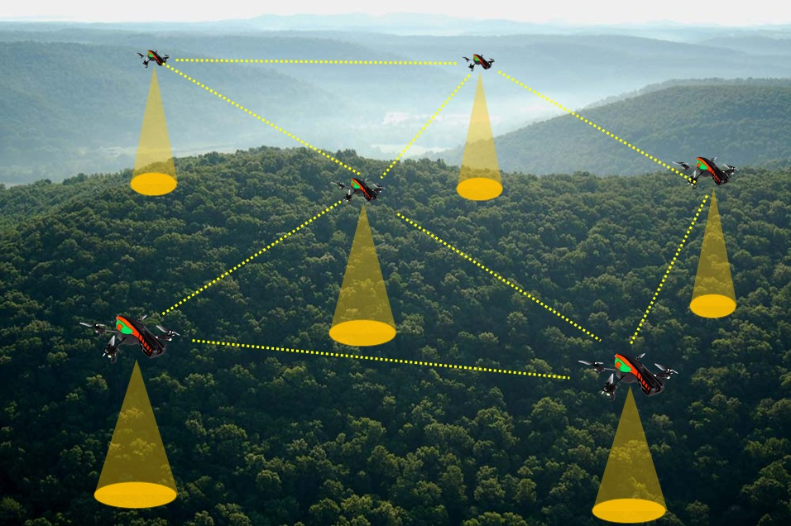

Figure 4 ‑ Network of drones, energy AND throughput are points of concern

Imagine if some drones are collecting some data and sending it to a command and control base (Figure 4). If the application at each drone has low data rate requirement, it does not require too much throughput, instead they could be better off having longer delays in the end-to-end transmission, and saving energy at the same time (Figure 4). For high data rate requirement, the focus is more on throughput. In this project the team will simulate such scenario, combining both throughput and energy. Given that each node only requires a certain amount of throughput, how can the packets be routed so that the network of drones can stay "alive" longer, and the communication to the C&C is not broken?

**(4) Dynamic routing mechanism design in faulty network**

Figure 5 ‑ Faulty network: how to route if a node suddenly stops working for a while?

The team will simulate a mesh network where nodes and links may fail (Figure 5). Nodes and links may fail intermittently, as an input to the simulation, each node and link will have a certain probability to fail. When such failure occurs, the network must adapt and re-route to avoid the faulty link/node.

# Rubrics for the project grading

CPE 400: 20% of the total grade

**Project Submission due by Monday, Dec 12th, 2022**

Deliverables:

1. **Code:**
   1. **[3] Turning in code that compiles and runs properly** 
      1. Code compiling properly and providing results as explained in the report: 3;
      2. Code compiling but not providing results as explained in the report: 1;
      3. Code not compiling: 0
   2. **[2] Documenting the code**
      1. Clear explanation of the entire code: 2;
      2. Partial explanation of the code: 1;
      3. No explanation of the code: 0
2. **Technical Report**
   1. **[5] A report explaining the functionality of the protocol**
      1. Protocol/functionality addressed extensively in details with as many realistic aspects as possible + error handling scenarios: 5;
      2. Protocol/functionality addressed with some details and some error handling but not extensive: 3;
      3. Unclear explanation of the protocol: 1;
      4. No explanation: 0
   2. **[5] Out of the box thinking: novel contribution**
      1. Important Novel Protocol/functionality contributed with visual simulations and details: 5;
      2. Important Novel Protocol/functionality contributed but explanation not clear: 3;
      3. Unclear/vague explanation provided: 1;
      4. No Novel contribution provided: 0
   3. **[5] Results and analysis of the results**
      1. Results and analysis contributed with details: 5;
      2. Results and analysis contributed but explanation not clear: 3;
      3. Results mentioned but no analysis provided: 1;
      4. No results provided: 0